**PERFORMANCE EVALUATION**

In this section we study the performance of the proposed algorithms through experimental simulation and find new logic's.We also investigate the impact of parameters: the network size i.e. the number of sensor nodes, the number of time slots in which the entire tour is divided and the maximum number of time slots in which one sensor can send data.

1. **Experimental environment setting**

We consider a network consisting of 100 to 500 sensors randomly deployed along a given path of a mobile sink. We assume that all sensors have identical maximum transmission ranges *Rmax* of 200 meters. The entire path is divided into 100 to 500 time slots. Hence each value of number of nodes is paired with each value of number of time slots and checked in a test set. N is the number of sensor nodes and T is the number of time slots for each test set. The data matrix is a N x T matrix, for each test run, where a data in i,j cell of the matrix denotes that ith sensor can send this much of units of data in the jth time slot. A value of zero indicated no transfer of data due to energy or range reasons. Each sensor is powered by a 10*mm* × 10*mm* square solar panel and its battery capacity is *, 10,*000*Joules*. We here adopt the communication parameters of real radio *CC*2591 , where the energy transmission consumption is 300*mJ/s*, and the available data transmission rates and corresponding distances are: 250*Kbps* between 0 and 20 meters, 19*.*2*Kbps* between 20 and 50 meters, 9*.*6*Kbps* between 50 and 120 meters, and 4*.*8*Kbps* between 120 and 200 meters. We set the duration of each time slot *τ* is 1 second in the default setting.

×

×

1. **Performance evaluation of algorithm**

We first study the performance of algorithm C_Schedule by varying *n* from 100 to 500 while *rs* is set at 5*m/s* and 10*m/s*,respectively,and then we propose our own algorithm by taking into consideration the future data as well i.e. the amount of data the sensors will be able to send in future.

We then record and compare the network utilities delivered by both the algorithms and then we observe that the network utility of our approach is greater than that of C_Schedule.

**TABLE COMPARING NETWORK UTILITY OF BOTH APPROACHES**

|  |  |  |
| --- | --- | --- |
| **NUMBER OF SENSORS** | **PROPOSED APPROACH** | **OUR APPROACH** |
| 25 | 2.8284 | 3.5033 |
| 50 | 3.4157 | 3.6056 |
| 75 | 3.9077 | 4.3589 |
| 100 | 4.2444 | 5.3436 |
| 125 | 4.4226 | 6.7082 |
| 150 | 4.7046 | 7.9373 |
| 175 | 5.0899 | 9 |
| 200 | 5.4324 | 10 |

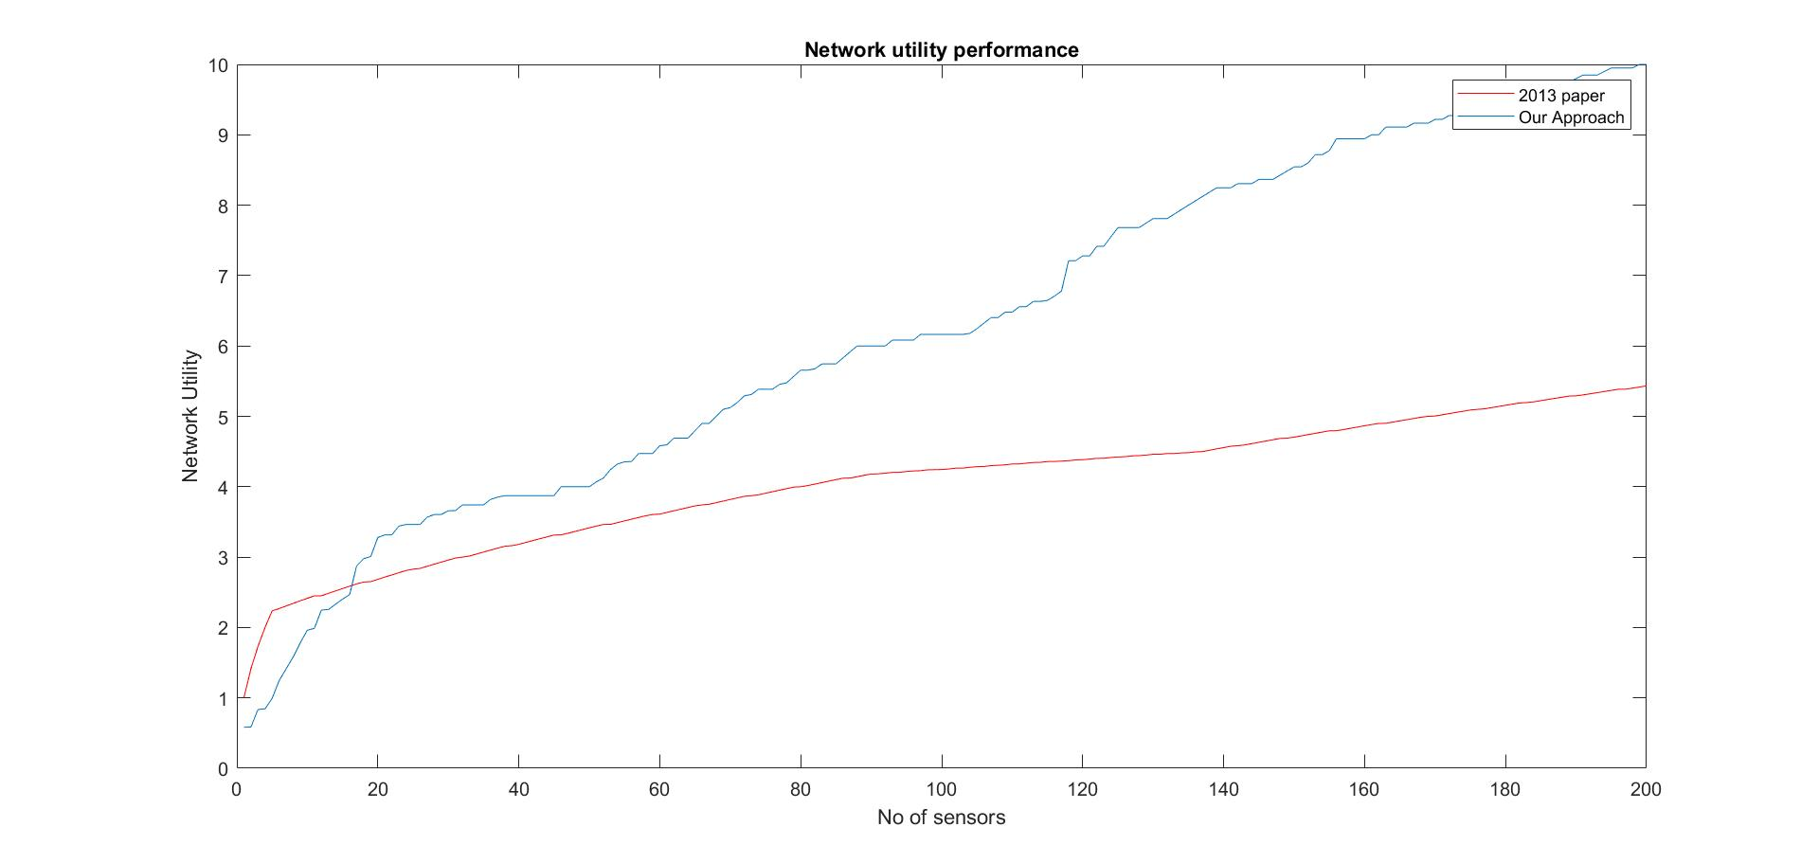

**Effect of increase in number of nodes**

Our Approach performs better than the 2013 paper algorithm but the difference in performance is more for greater number of nodes.

**Effect of increase in number of time-slots**

Our Approach performs better than the 2013 paper algorithm and the difference in performance is even better when we increase the number of time slots.

**CONCLUSION**

In this paper we studied mobile data collection in an energy harvesting sensor network with a path-constrained mobile sink. Firstly,we implemented the C_Schedule algorithm and then updated the utility function by proposing

our approach assuming that the global knowledge of the entire network is available.

The updated utility function will take into consideration the future data as well so as to collect maximum amount of data from the sensors that will not be able to contribute in future.